VELAMMAL ENGINEERING COLLEGE

(An Autonomous Institution)

CHENNAI–600066



ENDNOTE-CITATION AND REFERENCE MANAGEMENT TOOL FOR TECHNICAL WRITING

Organized By
DEPARTMENT OF
PHYSICS

SUBMITTED TO

ENTREPRENEURSHIP DEVELOPMENT CELL LEMON IVY

VELAMMAL ENGINEERING COLLEGE
(An Autonomous Institution)

Department of Physics

- Title of the Event : ENDNOTE-CITATION AND REFERENCE MANAGEMENT TOOL FOR TECHNICAL WRITING (Exclusive for Faculties)

- Resource Person : Dr. T. A. REVATHY

ASSISTANT PROFESSOR
DEPARTMENT OF PHYSICS
VELAMMAL ENGINEERING COLLEGE
CHENNAI

3. Date : 14-08-2024

- Session Type : Offline

- Program Type : PPT presentation
- Annexure- I : List of Participants

- Annexure- II : Brochure,
- Annexure- III : Photographs




Ms. G. Hamsavalli  Assistant Professor  Event Coordinator  Department of Physics | Dr. S. Shahil Kirupavathy  Professor & Head  Convener  Department of Physics

ANNEXURE-I

Table 1: List of Participants
List Participant

Sl. No | Name | Qualification | Designation
 | Dr. S. Shahilkirupavathy | M.Sc., M.Phil., Ph.D | Head and Professor
 | Dr. V. Ramesh Kumar | M.Sc., Ph.D | Associate Professor
 | Mrs. G. Hamsavalli | M.Sc., M.Phil., (Ph.D) | Assistant Professor II
 | Mr. Moses V.G. Isaiah | M.Sc., M.Phil., (Ph.D) | Assistant Professor I
 | Dr. J. Arumugam | M.Sc., M.Phil., Ph.D | Assistant Professor
 | Dr. M. Jayachandiran | M.Sc., Ph.D | Assistant Professor
 | Mrs. D. Anitha Jennifer | M.Sc., M.Phil., (Ph.D) | Assistant Professor
 | Mr.V. Baskaran | M.A.,M.Phil | Asst. Professor III &Head
 | Ms.S. Sugapriya | M.A.,M.Phil., (Ph.D) | Assistant Professor
 | Mr.A. Balaji | M.A.,M.Phil. (Ph.D) | Assistant Professor
 | Mr. Anand | M.A.,M.Phil., | Assistant Professor
 | Ms.J.Latha | M.A.,M.Phil., SET., (Ph.D) | Assistant Professor
 | Dr. M. Vinothkumar | M.A., B.Ed.,M.Phil.,Ph.D | Assistant Professor
 | Mr. V. Anand | M.A., B.Ed., M.Phil., (Ph.D) | Assistant Professor
 | Ms.G.M.Archana | M.A., M.Ed., M.Phil., NET | Assistant Professor
 | Mr. Kirubakaran Amalraj | M.A., B.Ed., M.Phil., SET | Assistant Professor
 | Dr. A. Mohamed Sikkander Abdul Razak | M.Sc., M.Phil., Ph.D | Associate Professor & Head
 | Mrs. Sasikala | M.Sc., M.Phil. | Assistant Professor
 | Mrs. Ramanachiyar | M.Sc., M.Phil. | Assistant Professor
 | Mr. Niruban Balu | M.Sc., M.Phil. | Assistant Professor
 | Dr. Geetha | B.E., M.E., Ph.D | Associate Professor

ANNEXURE –II

(BROUCHER, REGISTRATION FORM)

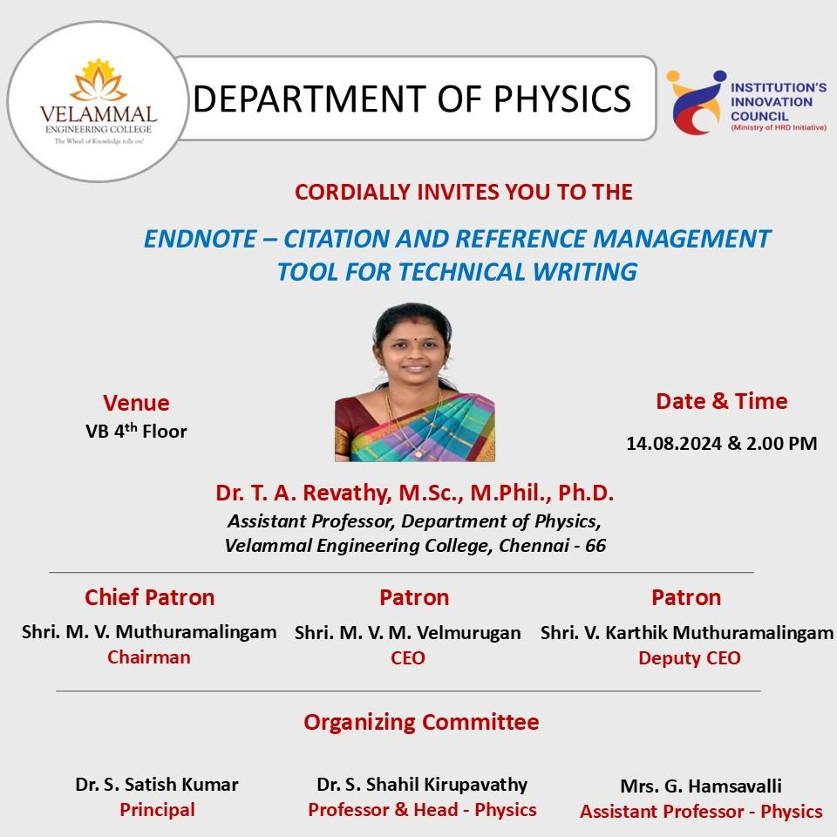

Figure 1: ENDNOTE-CITATION AND REFERENCE MANAGEMENT TOOL FOR TECHNICAL WRITING

Dr. T. A. Revathy, Assistant Professor in the Department of Physics at Velammal Engineering College, delivered a lecture on "ENDNOTE - Citation and Reference Management Tool for Technical Writing." The event was organized by the Department of Physics, with Dr. Shahilkirupavathy serving as the convener and Mrs. G. Hamsavalli as the event coordinator. Faculty members from the Departments of Physics, Chemistry, EEE and English attended the session, actively engaging with the speaker and seeking clarifications on the topic.

ANNEXURE –III
Photographs

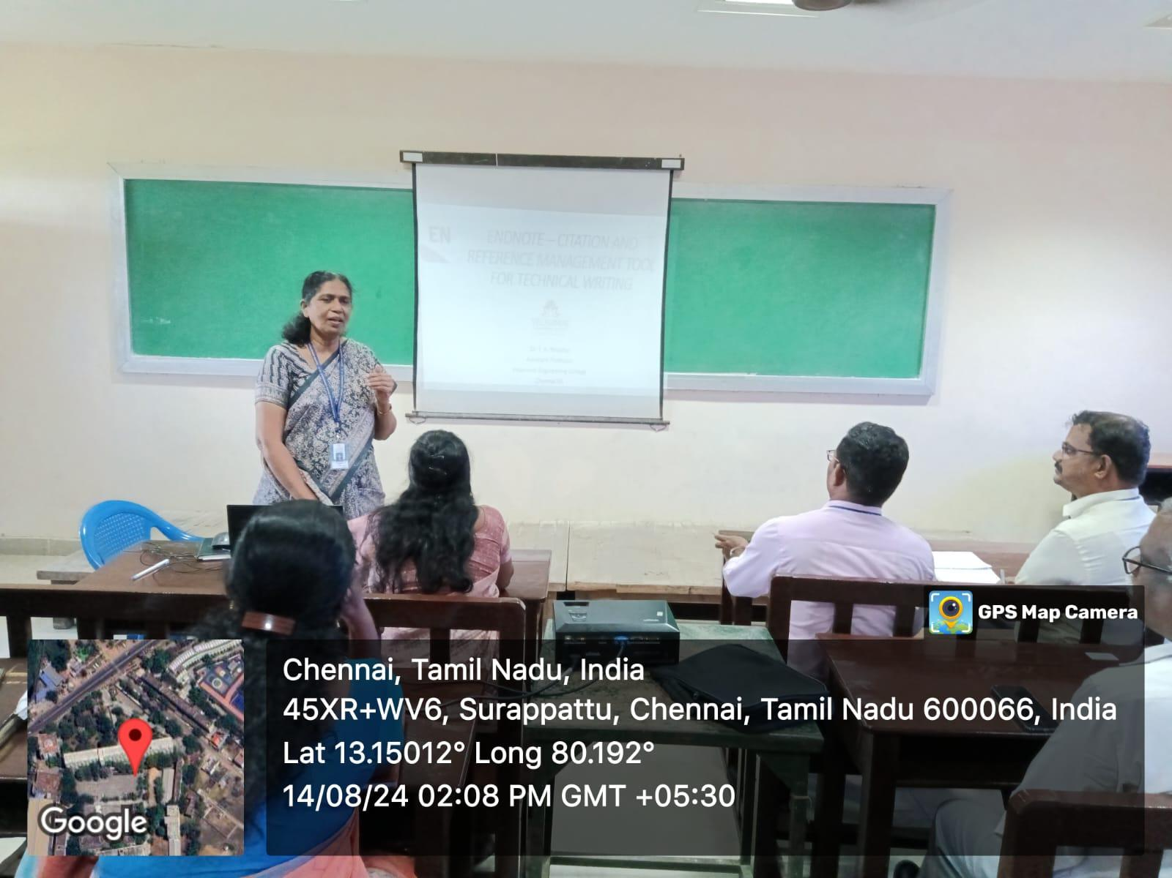

Figure 2: The invited speaker being welcomed by Dr.S.Shahilkirupavathy.

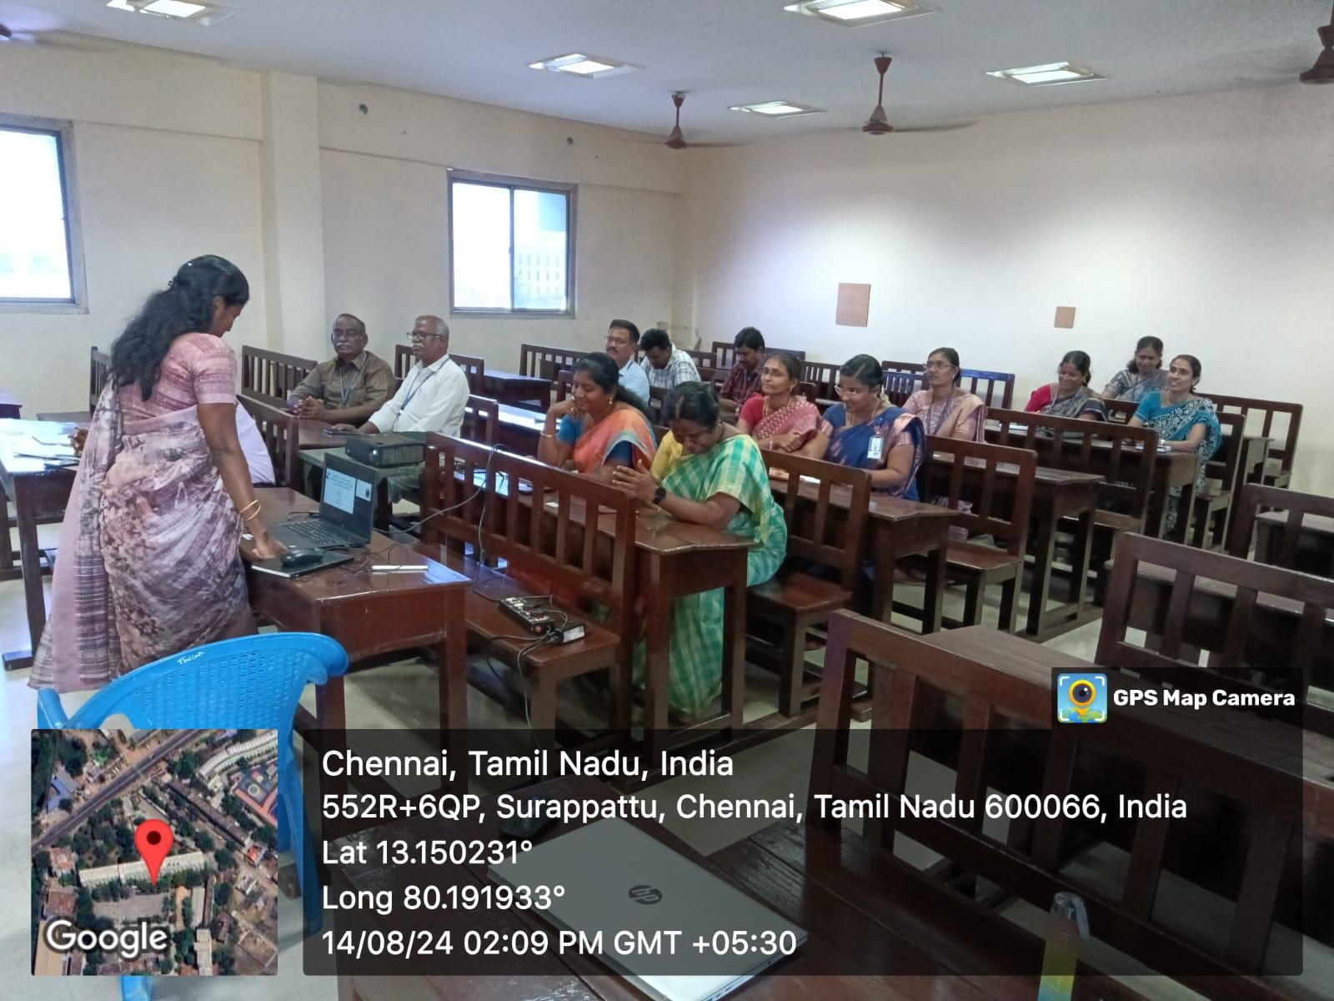

Figure 3: The speaker has explained about usage of ENDNOTE Tool for Research.

